1. Difference between set and Hashset?
2. Difference between map and HashMap?
3. Difference between list and Array List?
4. How we can create the custom Exception?
5. What is SOLID design principle?
6. What is the feature of Java 8.0?

Ans: a) Lamda (->) help to reduce the no of line of code.

b) Stream API

c) option: if present: return the Boolean value

d) Nason Engine

1. Explain Difference between: abstract method, Static method, default method in interface.

* We cannot override the static method. Static method can be loaded only.
* If we have to override, then we have to use the abstract method.
* We cannot override constructor. We cannot overload it.
* We cannot make the constructor as private. We can create the object but in same class.

1. Difference between error and exception/
2. What is throw & throws?
3. Stream Operation Flow:

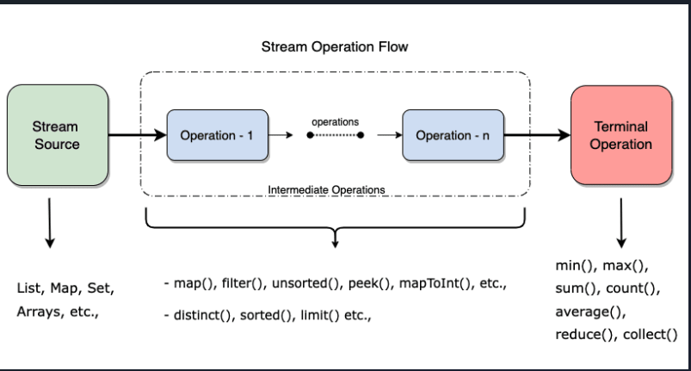

Stream is a function or API, which help to iterate the